HERO WEC 2024 Hydraulic Deployment Data Descriptions

Raw Data (TDMS, bag, and CSV Files)
Raw data from the 2024 HERO WEC hydraulic deployment was recorded and saved to multiple DAQs on the system. All RO subsystem data was recorded and saved to the onshore MODAQ system in the form of TDMS files. Buoy data was transmitted to the onshore MODAQ and saved in the form of TDMS files, however intermittent connection issues resulted in brief interruptions in the data stream received onshore and the bag files saved to the on-buoy MODAQ system were selected for use in the hydraulic data processing, as connection issues did not affect the data saved to this system. Anchor load cell data was saved to the submersible DAQ in the form of CSV files. It is important to note that due to this DAQ’s location near the seabed, its clock could not be synchronized using GPS like the other DAQs and an offset was applied to this time array during data processing to sync the air spring charge time with the on-buoy DAQ timestamps. The anchor load cell DAQ is powered by internal batteries and recorded data for just over four days after the HERO WEC was installed. The onshore MODAQ and load cell DAQs automatically applied slopes and offsets to each data stream before saving data in engineering units. Slopes and offsets were applied to data saved to the buoy DAQ during data processing. The slopes and offsets applied to each data stream as well as sensor descriptions can be found in tables 2 through 5. All slopes and offsets were calculated using NREL’s sensor calibration procedures. Diagrams of sensor locations within each subsystem can be found in the appendix.

DAQ | Group | Sample Rate [Hz] | Data Format | GPS Time Sync
Buoy MODAQ | AIN | 10 | bag file | Yes
Onshore MODAQ | VoltageAI | 2000 | TDMS file | Yes
Onshore MODAQ | CurrentAI | 1000 | TDMS file | Yes
Load Cell DAQ | LC | 10 | CSV file | No
Table 1: HERO WEC Sensor Groups
Sensor Name | Description | Units | Raw Output | Slope | Offset
PRESS_OS_2002 | Air spring pressure | psig | 4-20 mA | 15.625 | -62.500
PRESS_OS_1001 | Hydraulic pump output pressure | psig | 4-20 mA | 9.375 | -37.500
FLOW_OS_1001 | Hydraulic pump output flow rate | gpm | 4-20 mA | 2.477 | -9.908
POS_OS_1001 | Encoder | degrees | 4-20 mA | 22.712 | -89.922
Table 2: AIN group sensors.
Sensor Name | Description | Units | Raw Output | Slope | Offset
FLOW-ON-1001 | RO subsystem inlet flow | gpm | 4-20 mA | 1650 | -6.60
FLOW-ON-1002 | Clark pump inlet flow rate | gpm | 4-20 mA | 625 | -2.50
FLOW-ON-1003 | Brine discharge flow rate | gpm | 4-20 mA | 1650 | -6.60
FLOW-ON-1004 | Permeate flow rate | gpm | 4-20mA | 82.5 | -0.33
CND-ON-1001 | RO inlet conductivity | micro-Siemens | 4-20 mA | 6250000 | -25000
CND-ON-1002 | Permeate conductivity | micro-Siemens | 4-20 mA | 312500 | -1250
Table 3: CurrentAI group sensors.
Sensor Name | Description | Units | Raw Output | Slope | Offset
PRESS-ON-1001 | RO subsystem inlet pressure | psig | 0-10 V | 15 | 0
PRESS-ON-1002 | Clark pump inlet pressure | psig | 0-10V | 10 | 0
Table 4: VoltageAI group sensors.
Sensor Name | Description | Units | Raw Output | Slope | Offset
LC-ST-1001 | Anchor load cell | lbf | mV/V | 4586.293 | 0.043
Table 5: Load cell DAQ group sensors.
Processed Subsystem Array Data (Parquet Files)

Details of Products (columns) Added to Original Data

Quality Control (QC)
Data was processed to identify and correct any out of bounds values using a QC process developed by NREL. This process compared each individual value to the sensor’s measurement limits and identified all out of bounds values. A new qc_<original_channel_name> array was built for each raw data array to store these QC flag values. In these arrays, a value of zero indicates that the sensor’s reading was within bounds at a given timestamp, a value of 1 indicates that a data point was above the maximum value which the sensor can measure, while a value of 2 indicates that a data point was below the minimum value which a sensor can measure.
Value Added Products (VAP)
In this process, Value Added Products (VAPs) were produced to allow for thorough analysis of the data. VAPs in this data set are sorted into two categories, standard VAPs (arrays prefixed with vap_) are arrays where raw data was modified to become usable for calculations (such as applying phase shifts to the encoder data to remove discontinuities at zero crossings), and calculated VAPs (prefixed with calc_) are arrays where calculations were performed to provide data which could not be directly measured. Calculated VAPs are present only in the final output and summary data files.
Zero Crossing Fixes on POS-OS-1001
360-degree offsets were applied to portions of the encoder data to remove discontinuities at locations where the 0/360-degree mark on the encoder was crossed. This step was performed using an NREL developed script which identifies these events, checks for and removes anomalous data points recorded as the encoder outputs rapidly changes between the limits of its range, and then uses MATLAB’s unwrap function to shift the phase angles of the data set resulting in a continuous encoder position profile. This array is saved as vap_POS_OS_1001_UW.
Synchronization of LC-MOOR-1001 with WEC and On-Shore DAQs
Fixing the zero crossings on POS-OS-1001 enabled the comparison of calc_Winch_V and LC-MOOR-1001 to identify the timestamps of the airspring charge time on both the load cell DAQ and onbuoy DAQ. The load cell DAQ clock was then offset to align the air spring charge time stamp with the timestamp of this event recorded by the GPS synchronized on buoy MODAQ system. Following this data processing, the data from each sensor along with its qc array and processed data (when applicable) was put into an individual parquet file.
Alignment and resampling of measurements with different sampling rates
Next, these files were grouped to build a parquet file of data for each subsystem. In this step, the anchor load cell data was resampled to the on buoy DAQ timestamps and data from PRESS-ON-1001 and PRESS-ON-1002 was down sampled to match the timestamps of the rest of the RO subsystem sensors on the CurrentAI group.
Subsystem | Abbreviation | Sample Rate [Hz] | Arrays
WEC | WEC | 10 | LC-MOOR-1001 (Resampled)  POS-OS-1001  vap_POS_OS_1001_UW  vap_POS_OS_1001_UW_S  PRESS-OS-2002  WEC_Timestamp_NS  WEC_Datetime
Reverse Osmosis System | RO | 1000 | FLOW-ON-1001  FLOW-ON-1002  FLOW-ON-1003  FLOW-ON-1004  PRESS-ON-1001 (Down Sampled)  PRESS-ON-1002 (Down Sampled)  CND-ON-1001  CND-ON-1002
Table 6: Hydraulic configuration subsystems.
Once data from each group was resampled to common timestamps, Python was then used to perform instantaneous power calculations within each subsystem along with additional calculations useful for understanding system performance. Next, the RO subsystem data and VAPs were down sampled to 10 Hz to align with the WEC subsystem data producing a single common timestamp data set for the full deployment. A description of each calculated array can be found in table 6. Velocity calculations were performed using Python’s np.gradient function to calculate an instantaneous velocity array from position data using numerical differentiation. This function primarily uses the central difference method; however, the forward difference and backwards difference methods are used at the beginning and end of the array to avoid the loss of data points in the velocity array.

Name | Description | Units
Calc_V_Encoder | Encoder velocity calculated using python’s np.gradient function | rpm
Calc_V_Winch | Winch velocity. Calc_V_Encoder multiplied by 4.5 (first stage spring return ratio) | rpm
Calc_V_Gearbox | Gearbox output shaft velocity. Calc_V_Winch multiplied by 11.28 (gearbox ratio) | rpm
Calc_P_abs | Instantaneous absorbed power ((Calc_V_Winch [rpm]*(D_Winch [ft]/2)* LC_ST_1001 )/5252 [rpm*ft*lbf/Hp])*0.7457 [kW/Hp]. This calculation is not performed after data collection on the load cell DAQ stops. | kW
Calc_Filter_DP | Pressure differential across RO pre-filter (PRESS_ON_1001 – PRESS_ON_1002) | psi
Calc_ACC_Flow | Flow rate into onshore accumulators (FLOW_ON_1001 – FLOW_ON_1002) | Gpm
Calc_P_Hydraulic_1 | Hydraulic power at pump outlet ((PRESS_OS_1001[psig] * FLOW_OS_1001 [gpm])/1714 [psig*gpm/Hp])*0.7457 [kW/Hp] | kW
Calc_P_Hydraulic_2 | Hydraulic power at RO system inlet ((PRESS_ON_1001[psig] * FLOW_ON_1001 [gpm])/1714 [psig*gpm/Hp])*0.7457 [kW/Hp] | kW
Calc_P_Hydraulic_3 | Hydraulic power at Clark pump inlet ((PRESS_ON_1001[psig] * FLOW_ON_1001 [gpm])/1714 [psig*gpm/Hp])*0.7457 [kW/Hp] | kW
Calc_Recovery_Ratio | RO recovery ratio during test (FLOW_ON_1004/FLOW_ON_1002) | -
Table 6: Calculated arrays.
Half Hour Summary Data (Parquet Files)
A separate Python script was then utilized to perform summary calculations on each half hour data set and output an additional parquet file summarizing device performance during each half hour of operation. These calculations include data points useful for technoeconomic analysis of the device and for understanding long term operation of coastal WECs. A complete list of summary data contained in these files can be found in table 7.

Name | Description | Units
Duck_Wave_Height | Significant wave height recorded at Duck WaveRider buoy (CDIP #430, NDBC #44100) | m
Duck_Wave_Period | Peak wave period recorded at Duck WaveRider buoy (CDIP #430, NDBC #44100) | s
Duck_Wave_Power | Calculated power of seastate recorded at Duck WaveRider buoy (CDIP #430, NDBC #44100) | kW/m
Nags_Head_Wave_Height | Significant wave height recorded at Nag’s Head WaveRider buoy (CDIP #243, NDBC #44086) | m
Nags_Head_Wave_Period | Peak wave period recorded at Nag’s Head WaveRider buoy (CDIP #243, NDBC #44086) | S
Nags_Head_Wave_Power | Calculated power of seastate recorded at Nag’s Head WaveRider buoy (CDIP #243, NDBC #44100) | kW/m
Calc_P_abs_AVG | Calculated average absorbed power | kW
Calc_P_Hydraulic_1_AVG | Calculated average hydraulic power at pump output | kW
Calc_P_Hydraulic_2_AVG | Calculated average hydraulic power at RO system inlet | kW
Calc_P_Hydraulic_3_AVG | Calculated average hydraulic power at Clark pump | kW
Calc_Q_Pump_AVG | Average flow rate at pump output | gpm
Calc_Q_Feed_AVG | Average flow rate of water received at RO subsystem | gpm
Calc_Q_Clark_Pump_AVG | Average flow rate at Clark pump inlet | gpm
Calc_Q_Brine_AVG | Average flow rate of brine discharge | gpm
Calc_Q_Permeate_AVG | Average permeate flow rate | gpm
Calc_Eta_WEC | Calculated WEC efficiency (from winch to pump outlet) | %
Calc_Eta_Overall | Calculated system efficiency (from winch to Clark pump) | %
Calc_Loss_Transfer | Calculated losses across transfer hose | %
Calc_Volume_Pump | Total volume of water moved by hydraulic pump | gallons
Calc_Volume_RO | Total volume of water received at RO subsystem | gallons
Calc_Volume_PRV | Total volume of water discharged by pressure relief valves | gallons
Calc_Volume_Clark_Pump | Total volume of water received at Clark pump | gallons
Calc_Volume_Permeate | Total volume of permeate produced | gallons
Calc_Volume_Brine | Total volume of brine discharged | gallons
Calc_Tension_AVG | Average anchor line tension | lbf
Calc_Tension_Min | Minimum anchor line tension | lbf
Calc_Tension_Max | Maximum anchor line tension | lbf
Table 7: Summary data.
Nearby ocean observing buoys and weather stations were selected to provide wave resource insight during the HERO WEC deployment. Data from CDIP 243 (NDBC 44086) and CDIP 433 (NDBC 44100) during the timeframe of the HERO WEC deployment is provided with the HERO WEC data. These buoys are Waverider type buoys and are located significantly further offshore than the HERO WEC deployment location in 20-25 m water depth. Due to the different locations and water depths of the observing buoys relative to the HERO WEC, the data from these buoys should only be used as a reference of the sea states near the HERO WEC. The shallow water waves which the HERO WEC operates in are expected to have different heights, periods, and power than the waves measured by the wave rider buoy. Data from this buoy is included only to identify general trends in the sea state and should not be used for a performance analysis of the HERO WEC in individual sea states. Wind and atmospheric data recorded by the NDBC ORIN7 station located at the Oregon Inlet Marina is also provided. A total of seven environmental data files are available consisting of one data file for the ORIN7 station, and three data files for each ocean observing buoy. Of these three files, two are raw data files, one published by NDBC, and one published by CDIP, while the third file contains wave information calculated from the CDIP wave spectral density data using MHKiT. This file contains important information such as the energy period and wave power flux.
MATLAB Workspace
A Matlab script was then used to convert both the array data and summary data from parquet files to MATLAB workspaces. All data in these workspaces retains its original names from the parquet files. The processed Matlab Workspaces are accompanied by a data viewer script allowing the user to easily plot all array data over a specified timespan. To use the Matlab data viewer script, the working directory must be set to the location of the MHKDR submission 555 download and the variables “Visualization.Start” and “Visualization.End” must be manually set to the desired start and end times in UTC 24-hour date string format.

Appendix A: Locations of Sensors within HERO WEC Subsystems
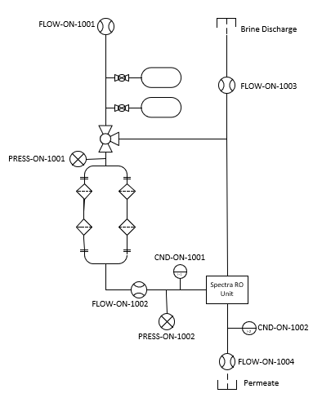
Figure 1: Location of RO system sensors.

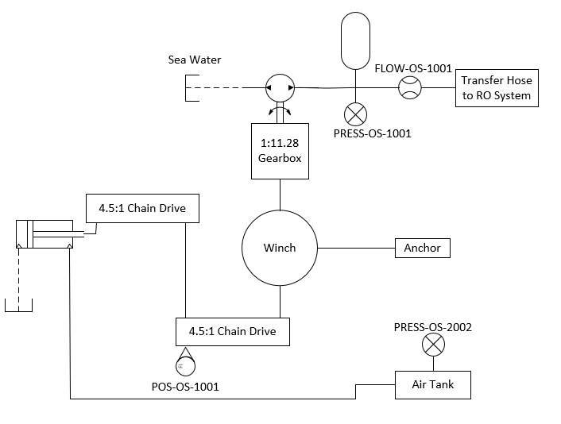
Figure 2: Location of on-WEC sensors.
Appendix B: HERO WEC Hydraulic Deployment Events
Event | UTC Time Stamp | Unix Timestamp [seconds]
Air spring charged | Thu Mar 14 2024 13:54:48 GMT | 1710424488
Transfer hose connected to RO subsystem (RO bypassed) | Thu Mar 14 2024 14:00:00 GMT | 1710424800
Onshore DAQ shutdown for software update | Thu Mar 14 2024 18:04:06 GMT | 1710439446
Onshore DAQ resumes data collection | Thu Mar 14 2024 18:05:19 GMT | 1710439519
Transfer hose disconnected from RO subsystem | Thu Mar 14 2024 18:18:00 GMT | 1710440280
Flow supplied to RO subsystem by electric submersible pump for RO commissioning (RO bypassed) | Thu Mar 14 2024 18:44:22 GMT | 1710441862
Electric submersible pump shutdown (end of RO commissioning) | Thu Mar 14 2024 19:54:08 GMT | 1710446048
Transfer hose connected with RO engaged (NREL defined start of hydraulic test) | Thu Mar 14 2024 19:57:45 GMT | 1710446265
Beginning of first RO pressure anomaly | Sat Mar 16 2024 07:50:00 GMT | 1710575400
End of first RO pressure anomaly | Sat Mar 16 2024 08:40:00 GMT | 1710578400
RO bypassed for system operation demonstration | Sat Mar 16 2024 15:10:56 GMT | 1710601856
RO engaged | Sat Mar 16 2024 15:12:44 GMT | 1710601964
Beginning of second RO pressure anomaly | Sun Mar 17 2024 07:24:00 GMT | 1710660240
End of second RO pressure anomaly | Sun Mar 17 2024 13:00:00 GMT | 1710680400
Beginning of third RO pressure anomaly | Mon Mar 18 2024 01:55:00 GMT | 1710726900
Mooring DAQ stops recording data | Mon Mar 18 2024 12:49:36 GMT | 1710766176
End of third RO pressure anomaly | Mon Mar 18 2024 13:00:00 GMT | 1710766800
Beginning of fourth RO pressure anomaly | Tue Mar 19 2024 05:10:00 GMT | 1710825000
Hydraulic hose punctured from abrasion against anchor line | Tue Mar 19 2024 05:25:00 GMT | 1710825900
Table 8: Timestamps of important events during the 2024 HERO WEC electric configuration deployment.
Appendix C: Sensor Calibration Sheets
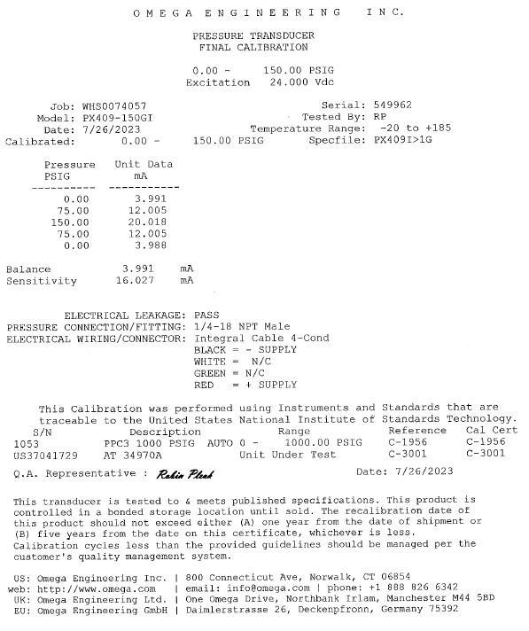
Figure 3: Manufacturer calibration sheet for HERO WEC pressure transducer.

Although the mooring DAQ and on buoy MODAQ are both designed to sample at 10Hz, slight variations in the sample rates of these DAQs combined with the fact that the mooring DAQ clock cannot be GPS synchronized due to its location near the seabed necessitated the use of resampling to align these timestamps as opposed to a simple interpolation method.
During the hydraulic deployment, there were four instances of a lower pressure being recorded on the pre-filter pressure transducer (PRESS-ON-1001) than at the post-filter pressure transducer (PRESS-ON-1002).During one of these instances, the team was able to verify with the analog pressure gauge that this reading was incorrect, but a root cause for the anomalies has not been determined (e.g. electrical noise, loose connector, etc.).

